* **MAKE OUT YOUR DREAM WITH DESTINATIONS**

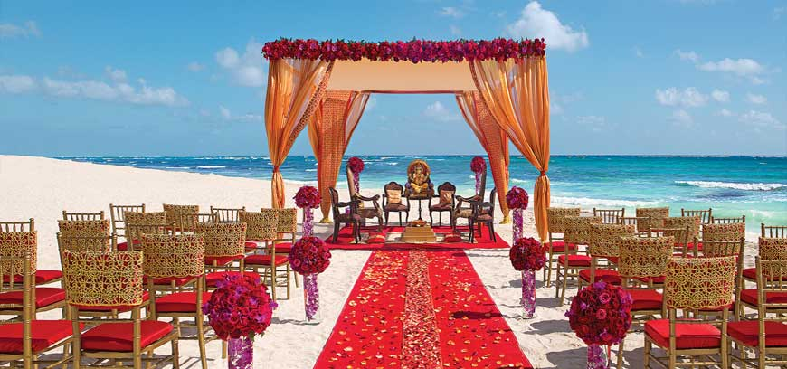

Destination wedding is an awakening dream of every couple as it is a lifetime experience and an amazing memory that will be cherished throughout their life. It has become a raging tradition over the last few years. In order to make it an exotic wedding filled with the magnificent beauty it is very important to hire a specialized and a perfect wedding planner. Wedding is a unique blend of grand celebration with the dear ones. HUMSAFAR Weddings help you to achieve your dreams and have the best royal destination wedding according to your choice in low budget.

We help you out in deciding the best place to have a fantastic destination wedding just according to you. The best part is that we provide you with the best in affordable rates. We offer a wide variety of venues to forge the wedding of true souls, making it a remarkable day in your life.

As the destination wedding is trending a lot, here are some of the best places to have a royal destination wedding :-

* **BEST DESTINATIONS WITHIN INDIA**

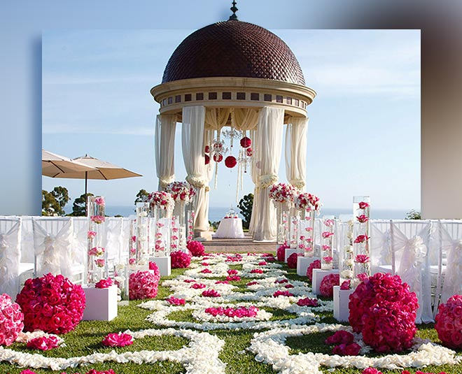

* **UDAIPUR- Venice of the east**

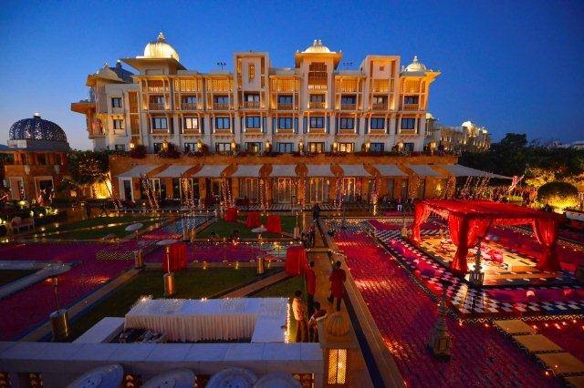 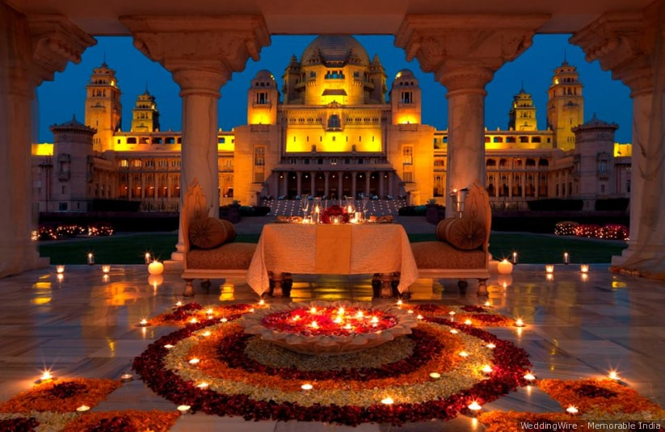

The beautiful city with palatial locations surrounded by aesthetic beauty is one of the most attracted tourists spot set up in the shadows of Aravalli mountains. The magical surroundings provide a natural ambience making it a truly memorable wedding.

* **JAIPUR- The pink city**
* 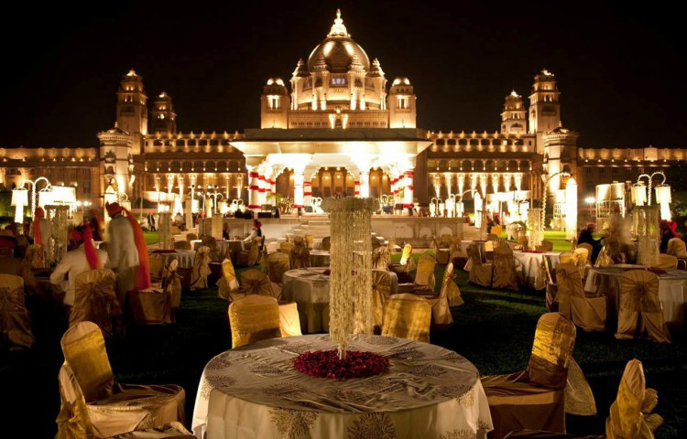

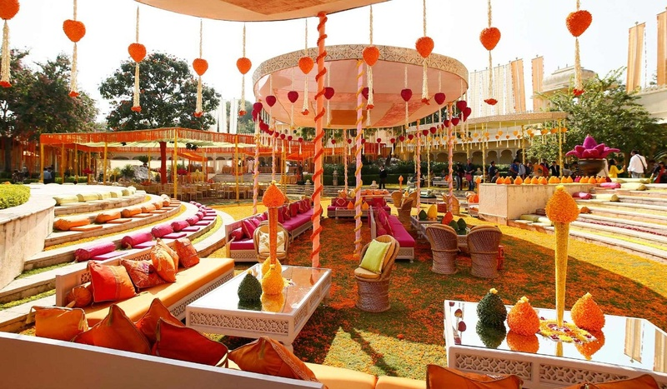

Jaipur is one of the top options in order to plan a destination wedding that would be far away from the hustle and bustle of a normal life. It offers spectacular wedding places, forts, hotels along with the natural beauty that magnifies the entire atmosphere. Moreover, it was also ranked as one of the top locations for destination wedding in India. The hotels, the romantic venues offer a luxury tradition to make the day much more special.

* **RISHIKESH- Gateway to the Himalayas**

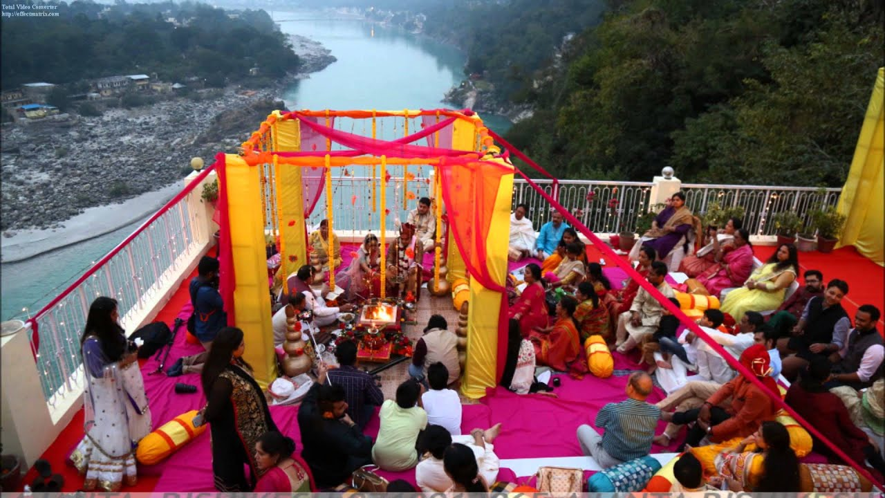

The best view to have a destination wedding at the mountain top with the blessing of the holy river Ganga, making the wedding much more blissful. It embraces the spiritual beauty with the essence of divinity. The blessing of Lord Vishnu also rests on the couple greeting them a prosperous and wealthy life ahead. The humming of river ganga, the beauty of mountains with the blessing of Gods and Goddesses along with the saying of sacred mantras made the day very special and amazing.

* **FOREIGN DESTINATION WEDDING**
* **ATLANTIS BAHAMAS-**

It provides a breathtaking view to soft sand beaches along with the dazzling sea waves with a brightening sunsets near the surroundings making it a romantic island for the lovely couples to forge their wedding near the sea coast. The cool breeze with windy air sprinkles love all over the atmosphere making love floating in the air.

* **FRANCE-**

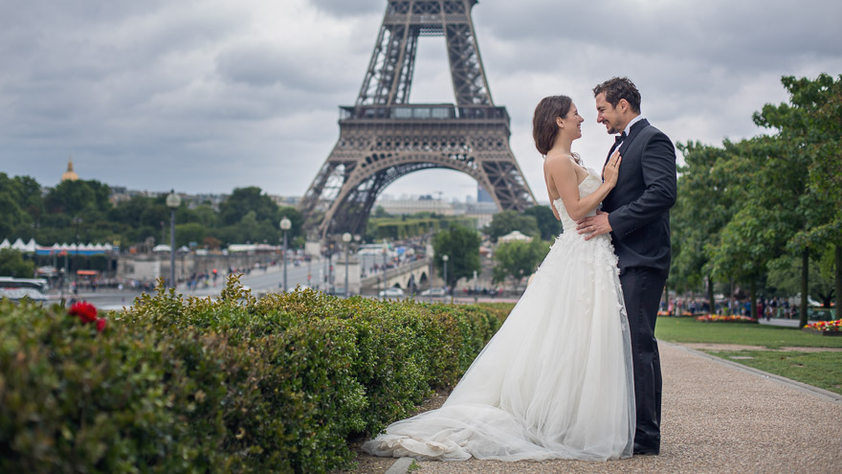

A large country with variety of cuisines along with the mixed weather makes one to plan destination wedding in France. The cool atmosphere, the natural flowing of rivers provides a cool temperature and saves us from a hot, sunny weather. We help you to fulfill all your dreams of chateau receptions, lavender fields, celebrating the best day of your life in a magical European atmosphere. Ringing of merry golden bells, holding a bouquet with bright fleur expressing amour towards each other. This is the best view and a magical beginning of a new journey into the love life.

So, if you’re really dreaming for a destination wedding, come join and start with us. We’ll help you turn all your dreams into reality. We have an exceptionally experienced team of the wedding planners who had gathered amazing ideas to plan a wedding anywhere around the town.

* **Rituals are course hero**

"The journey is much more beautiful than the destination"The wedding, one's life-changing moment isn't a shot of one day but a journey into the amalgamation of love, family and rituals most importantly.

Rituals are threads of interwoven love and care passed on to generations by the hands of those who respect and cherish them. Rituals are the sacred and amiable activities that have an attached importance and significance in one’s life. Wedding without rituals can never be perfect. The wedding ritual needs to be just perfect. No wedding is ever complete without proper rituals.

* **RING CEREMONY**

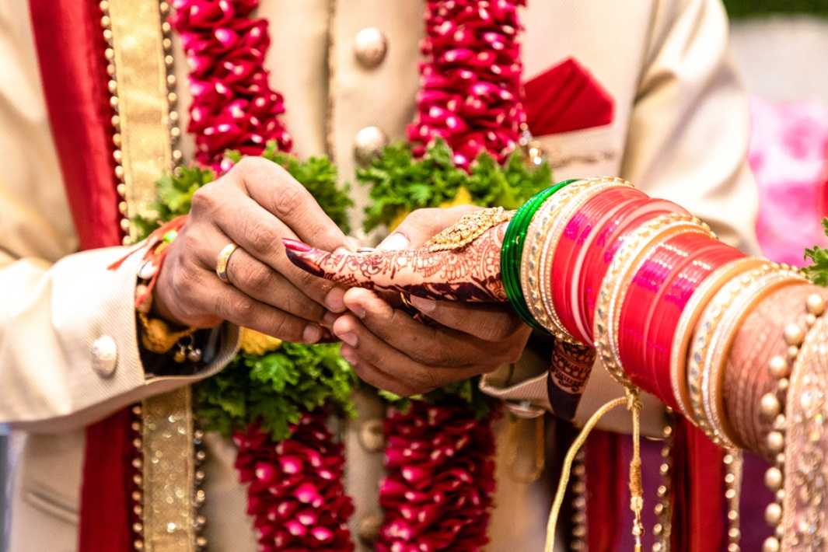

It all starts with engagement/ring ceremony. It implies the beginning of a new life very soon. This is a fresh start that needs to be captured in a perfect way. Rings are an evergreen symbol of love and togetherness exchanged by the couple on the engagement day. This day is special as it marks the beginning of a new life filled with love and togetherness. We, at HUMSAFAR, make sure that the arrangements are just perfect for a fresh start. Moreover, the decoration and arrangements have to be perfect in order to impress others. Humsafar weddings make sure that you enjoy every second, every moment of your special days. Thus, we work to achieve perfection in whatever we do. Parents who witness their children being showered with love is a picturesque view itself.

* **RASM-E-HALDI**

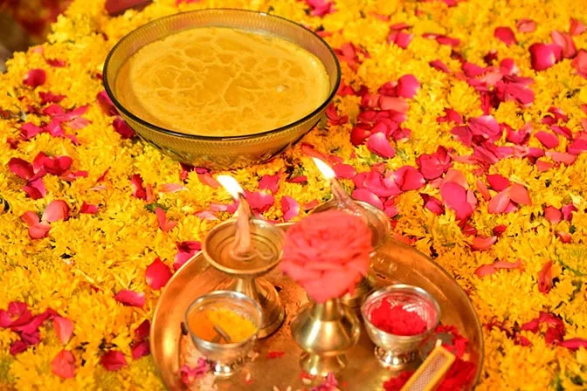

This is one of the traditional Indian wedding rituals. It is celebrated by both the families separately. Bright yellow colour haldi paste is applied on the skin of bride and groom with the help of mango leaves. Haldi is a symbol of purity, thus, it is believed that applying Haldi will also help the skin to glow and will bring happiness in their life.

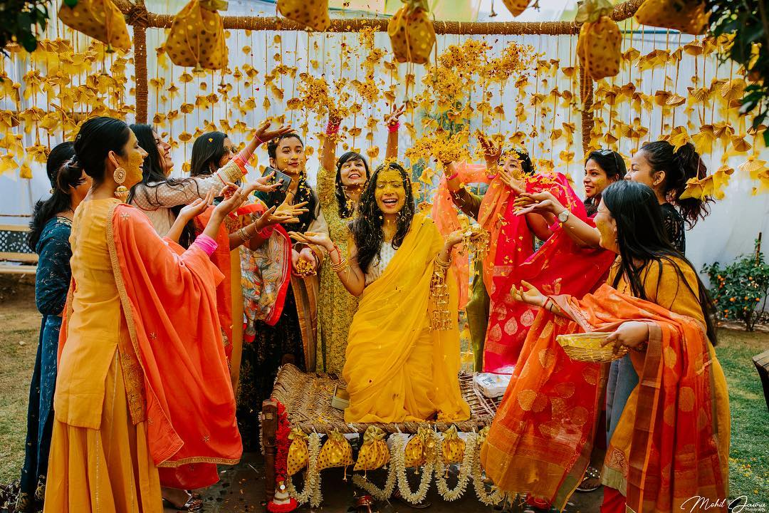 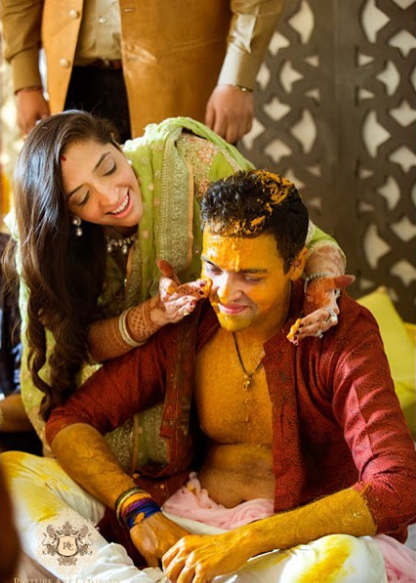

* **FLORAL MEHNDI DESIGN**
* 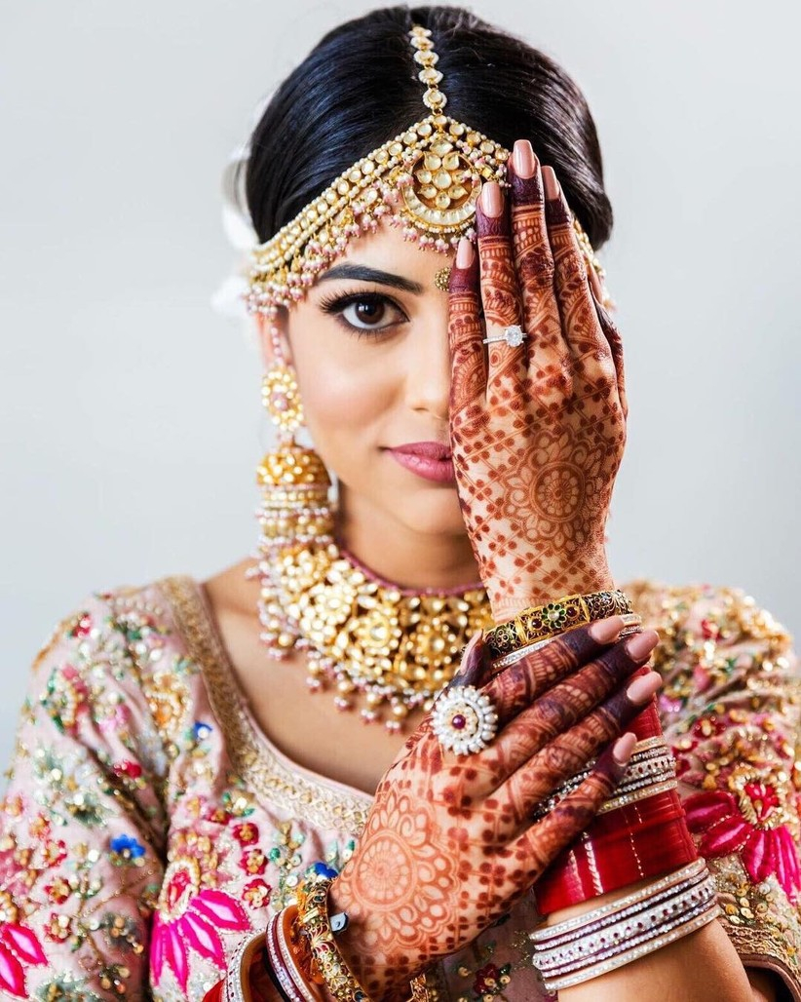

Those floral mehndi designs on your pretty hands aligned with decorative patterns. It involves greeting the bride/ groom, applying mehndi and feeding them with sweets. Then they seek blessings from their elders to have a fruitful, fresh start. This is further followed by sangeet where ladies sit around and sing bhajans, dance and express their love and contentment towards the love life of couple.

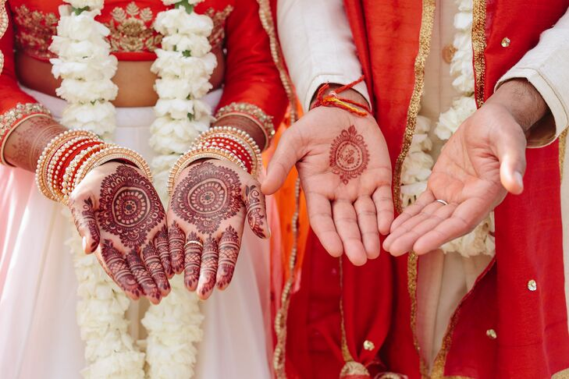

* **WEDDING DAY**

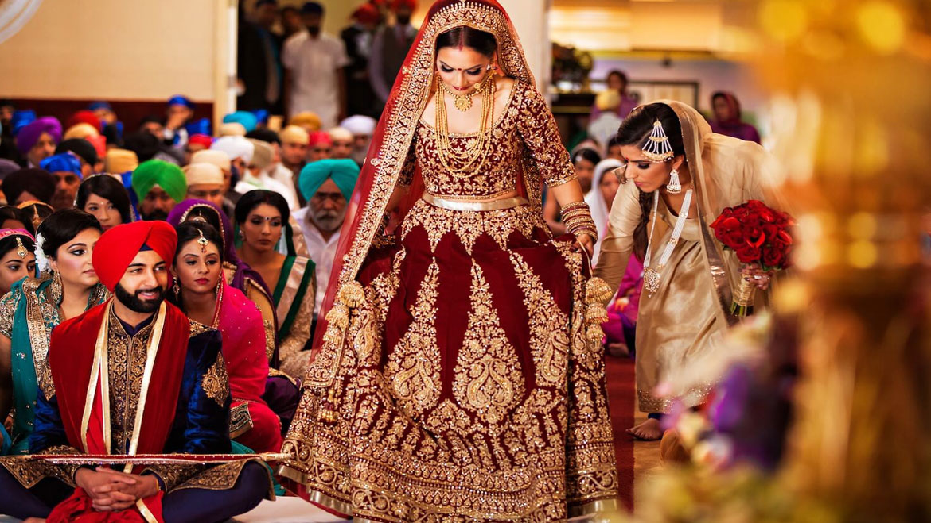

It commences with the entry of a glamorous bride, accompanied with her warrior brothers all along standing by her side at every ups and down in life. This stands to be a moment of pride for a sister to see her brother standing beside her. However, it becomes much more special with the beautiful decorations and ambience around with playing suitable background music and starring them with flashy lights. Finally, the left hand of bride is placed on groom’s right hand and their hands are joined together for life signifying togetherness and union of two lovely souls. This awesome moment is incomplete without the proper wedding decorations, themes.

All these special moments are very much connected to your heart. These get happier with your partner beside you, holding your hand and you vow to capture these in your heart. While heading towards a new sequence of life, the bride/groom needs the blessings and rituals are blessings from your forefathers that keep you loved and at most affectionate luck. We perfectly capture all these very special moments and knit them into the thread of love and togetherness for you.

So, every tiny step a bride takes towards a new life and much more are the things we take care of and never let our customers feel embarrassed in front of others.

**Elect your wear:**

Throw away the gathers on him let him fall for you, Throw away the pallu on him let him catch and walk. Let her day start with her decision. ‘With a dazzling look on her ramp, holding his hands tight’ –it happens!There are so many ways to select a perfect wedding wear. Here we will go with it!

* Right fit gives right look:

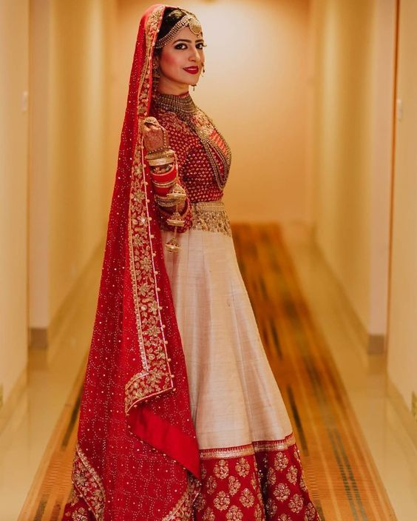

Technically, centimetres are more accurate than the inches that we often use in our daily life! But the main problem that people do is expecting exact fit in wrong selection of style in a garment. Not all styles are preferable for everyone. Each style has its own fit; some are semi-fit, loose fit, correct fit and tight fit. The selection of style depends on the body shape of the person. Apple, pear, triangle, inverted triangle, bell shaped and so on in classification of body shapes. As a wearer you should clearly know of what shape you are? And what are all the styles that will suit you?

Some styles will have a standard allowance of itself. So there you can’t change the fit. Only thing to be done prior is analyze your body type and wear according to it. In case, you are in a need to wear an attire which is out of your body type you can prefer corsets. But not always because it’s not a healthy suggestion since it may lead to breathing problems.

* **Go with a research**:

Research is always a long journey. But the style research is never uncomplicated for a woman. Hundreds of online hunt, thousands of window shopping and lakhs of style crossing us is highly enough for a style research. But when it comes to a wedding wear, go with specific things like wedding magazines, wedding website, etc. Even though you have a clear knowledge of what type of fit you are looking for, there are some others factors to be added in consideration.

Pick out all the styles which admire you and make a board out of it. Finally select the style.

Selection without a research is like telling the world ‘I’m out of trend!’

* Make it to your ease:

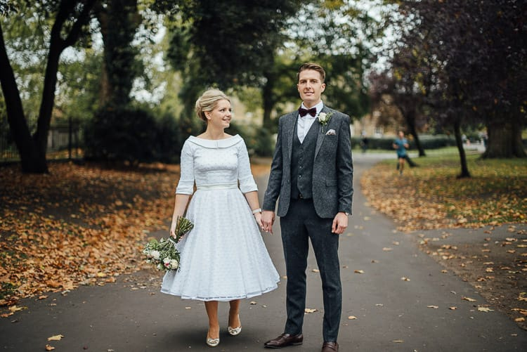

Everyone will have their area of comfort. That comfort can be physical, physiological and physiological. Wedding is a day where we have work for the whole day but should never forget to smile. And so, comfort is very essential. Some will not be comfortable with heavy garments and the other some will not feel comfortable with simple garments. So the word ‘ease’ has no defined definition on common as it varies from person to person. Comfort area mainly includes the texture of the fabric than compared with all other characteristics. This is because the texture of pure fabric can make her feel comfortable the entire day.

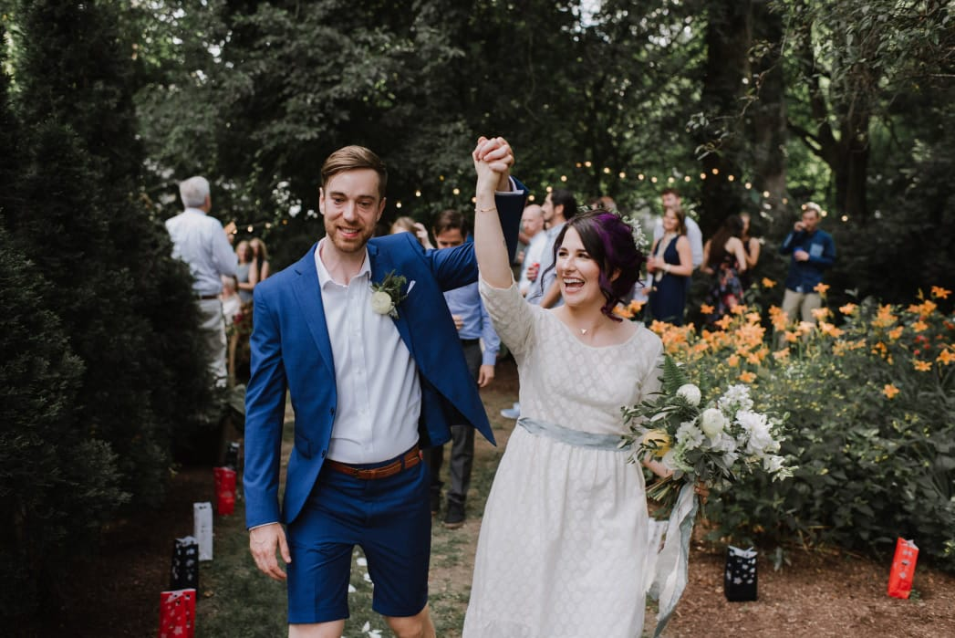

The major three points to be noted in your wedding purchase are these! Apart from it the budget, the attachments, colour therapy should be double checked. Everything joins to create a perfect outfit.Throw away the gathers on him let him fall for you, Throw away the pallu on him let him catch and walk. Let her day start with her decision. ‘With a dazzling look on her ramp, holding his hands tight’ –it happens!

A dream comes true moment for all is ‘Wedding’. So make your dream come true in all part of selection of the day. Thousands of pathways available for your day to go! **What matters is your state of contentment now and then.**

* **Sparkle of love:**

Love is the only thing the world craves for and it’s a magical feel. We can’t predict where will it start, when will it start, how will it start, why will it start, but it will happen one day!

Sore throat, fever and headache are the symptoms of COVID-19. Similarly love has its symptom and it is! ‘SMILE’. Whatever, you are going to sparkle love on someone first smile. Smile will build your relationship in a god manner.

Love is just a 4 letter word with a mix of emotions, behaviours, and beliefs associated with strong feelings of affection, protection, warmth, and respect for other person.

* Love with patience:

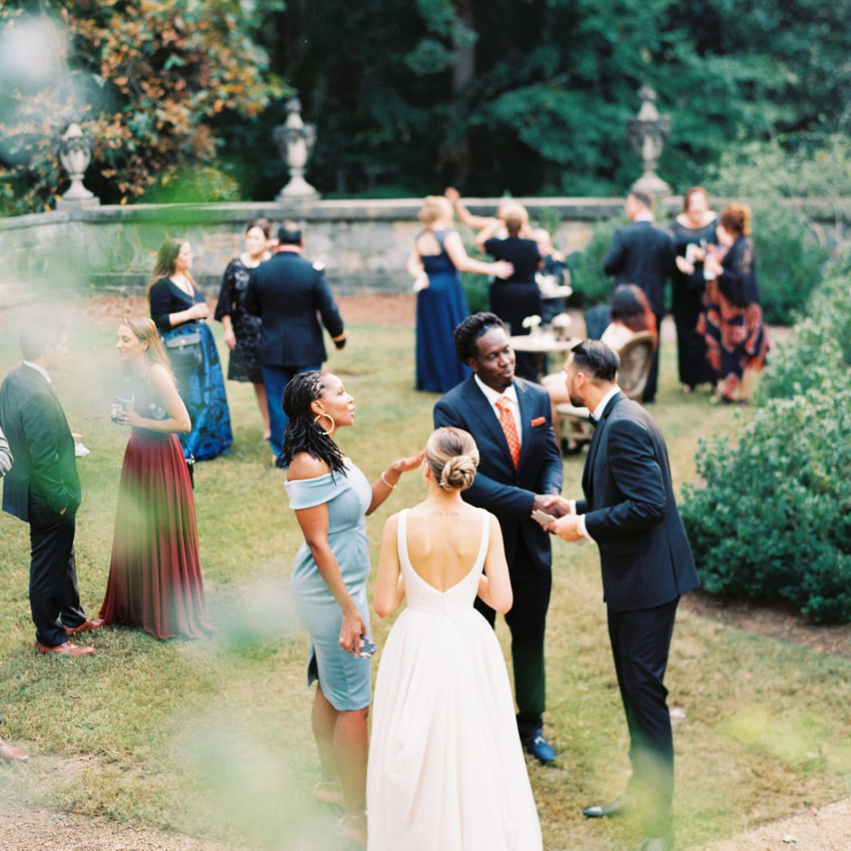

We know wedding is a memorable day to be marked and a day with full of load. There is a quick chance to get tensed by others. So the only thing to be tightly held is the mask of patience. We, Humsafar will do that for you with concern. When you meet with a shortage or an urgent need, obviously you will come across stress which will lead you to mess-up of things.

‘Be patience’ is an advice where as ‘Practise patience’ is a practical advice.Someone is asking something and you are in rush with words of answers i.e., lack of patience then it’s considered as a negative mark on your day. We will help you avoid this by proper prior planning and will surprise you with a day free of stress. All you need to do for the day is a ‘hearty smile’ to all around there.

Love with hospitality:

* 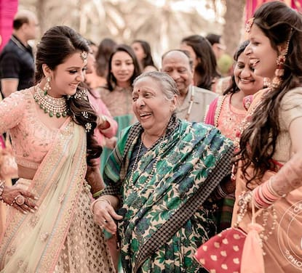

In simple, it is the feel of comfort. People will forget what you said, forget what you did to them, but people will never forget how you made the feel. You might be inviting your guests from foreign or other states. They will not be comfortable or known with the culture and trend that we a following. And so we will help you throughout that.

A day of love! Turn around and view all faces, only thing you can find is tears of love and words of love.

What are you going to give them all in return in your busy day? So here we are to make your busy day to a relaxed one. We plan things prior and help you check out all your guests. We love your loved ones as ours and make them wear a smile on the entire day. ‘Love with hospitality’ is all the guests expect! Don’t worry; Humsafar can do that with concern.

Love is hidden everywhere only way speaks is the way of sparkling it out. Let us join hands and sparkle it on your day to make it more blessed and memorable.

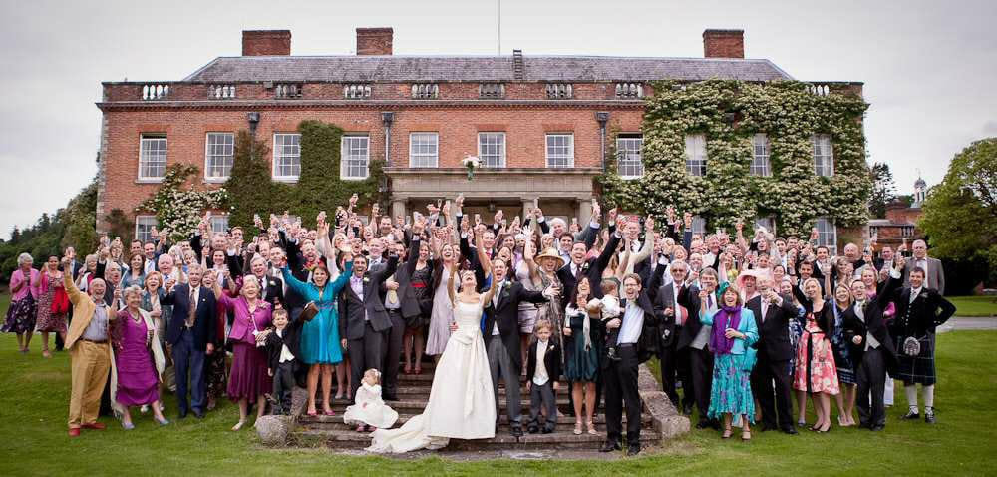

* **Go with the themes:**

Some of the most important chunks of your wedding include a perfect themed decoration. No wedding is complete without a decoration that suits the likings of the bride/groom and also attracts the people attending the wedding.

Decorations are known to mirror the personality of people who want it. It has to align with what the bride is wearing, what the groom likes and what is the character of everyone in the family. Decor varies in colours and themes. It can be bright somewhere but subtle the other place. At times it becomes really hard to choose one theme of your own. Though the themes are generally more customised by clients, there are some conventional inspirational themes that can be considered while neutralising their ideas at the same time. Let’s understand some of the most loved decorations so far.

**1. Fairy-tale theme:**

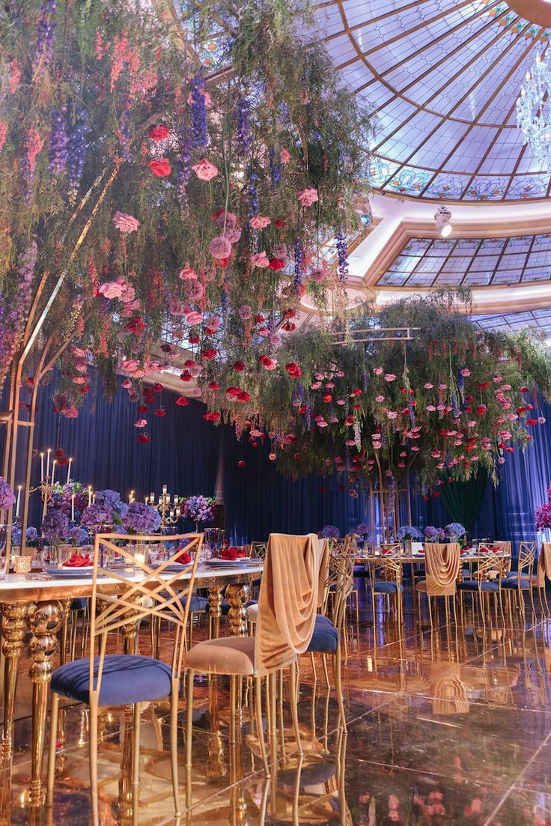

One of the most sought for the decorations is the fairy-tale style weddings. Taking inspiration from Disney princesses like Cinderella, Elsa, Rapunzel they are designed. The decor including huge curtains with fairy lights making it look like heaven like. Glass is most usually used and the bride can add Cinderella's heels in her outfit for wedding makes it look more subtle. The sangeet can have Victorian songs. White becomes the most used colour in the outfits here.

**2. Royal wedding theme:**

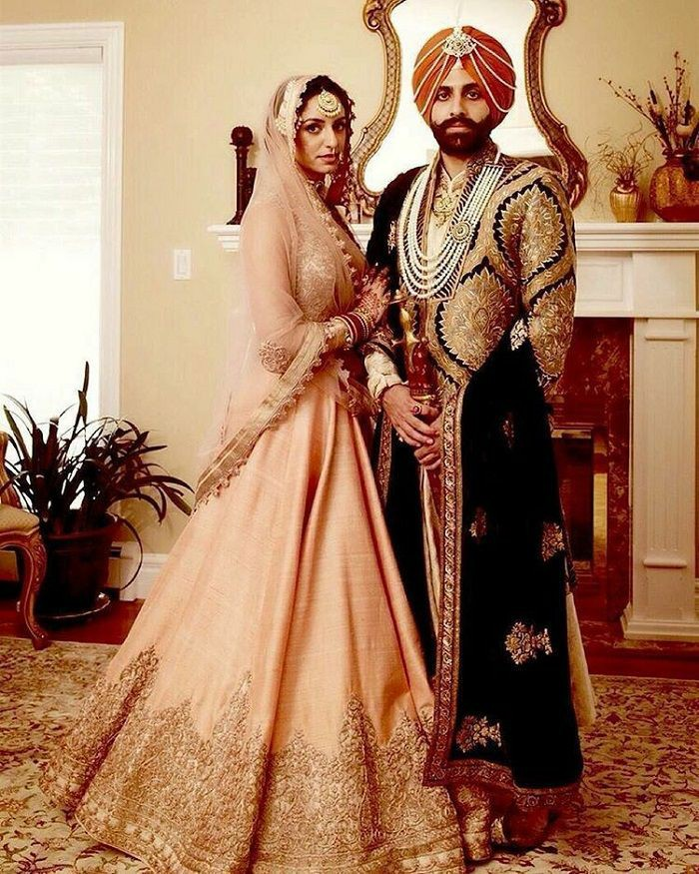

Some of the most majestic weddings are lush royal weddings with beautiful bright colours and a lot of decorations. With high tents, dazzling laser lights, loud DJ and every event royal-like. The venue should be traditional places like Umaid Bhawan and any hotels, resorts or even any place can be turned royal with perfect decorators. The family to should add little drama to make it more majestic like grand entry with shehnai and nagada. Grandiose should be added to the menu too with the use of copper vessels.

**3. Indoor green wedding theme:**

Many couples opt for a green wedding theme which is eco friendly. There are green decorations with plants and shrubs inside the wedding hall and a lot of fairy lights are used. People take this as a chance to do something for the environment and go for minimal use of resources and pollution. Dhol and shehnai are usually used for sangeet instead of the mainstream DJ. Catering is done accordingly. Candles, earthen lamps, Banana leaves are used for the main decor and a lot of flowering shrubs for the decor in other areas. This decided looks so greener, subtle and magnificent at the same time.

**4. Beach weddings:**

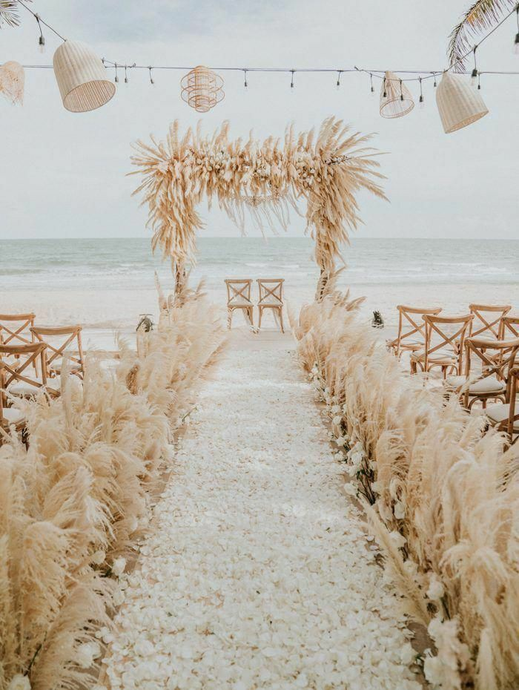

Goan style weddings or beach weddings are trendy these days. The couple can choose any destination on an island or a hotel where they can choose the decor accordingly. These weddings are fun with games too. The bride and groom choose offbeat outfits with dull colours that align with the beach beauty style. The bridesmaids can wear similar outfits with creative photographers in hand. Hats, sunglasses, umbrellas of colours are most sought for.